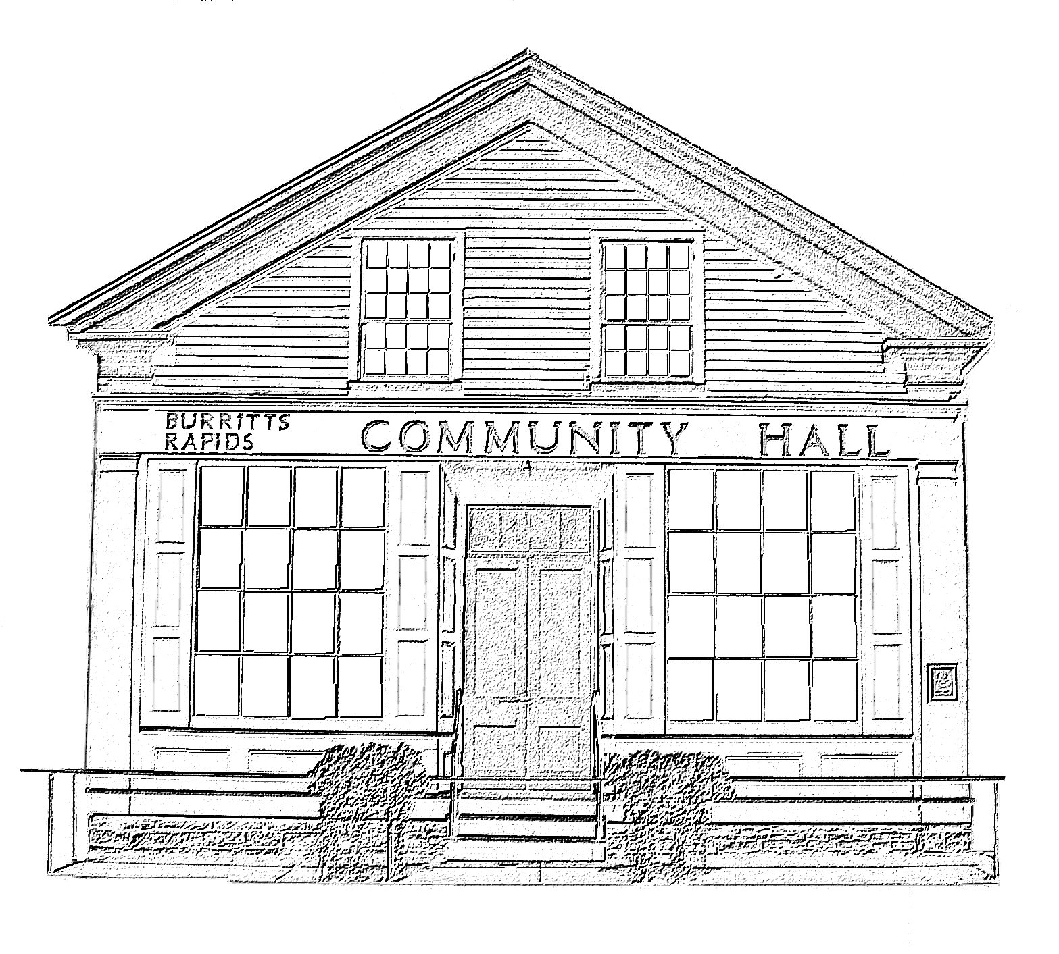
^{The} Burritt’s Rapids Community Association

Meeting of the Board of Trustees
Date: June 8 2011

Trustees Present:
John Dwyer, Patrick Gonneau, Jill MacDonald, Tiiu Wallner, Inge van Gemeren, Maureen Wilson

Community Members Present:

Aileen Weston

Agenda:

- Minutes last month (John)
- Finances (Jill)
- Rental Update
- Hall Issues
- New items

Meeting Started: 7:05 pm

Minutes last month (John)

The minutes of the April regular and special meetings were approved.

Finances (Jill)

The review of financial statements was deferred

Rental Update

Directors were informed that the karate club had decided to rent the Hall every week. (Upon question raised by Patrick, it was confirmed that sufficient insurance protection was in place.)

There was a general discussion of up-coming events, as well as events that occurred the previous month during the agent’s absence. All went well.

Hall Issues

There was a discussion about the humidity levels/water of the basement space used by the artist/renter. Patrick indicated that the exterior slope had been regarded. (Dick Hegen pitched in with his tractor. Many thanks!) He asked those on the Greening Committee to keep an eye on the area that had been seeded. Patrick also noted that the A/C run-off hose should have been vented through the wall. This was being done. It was hoped that these efforts would resolve matters. Patrick was to maintain a watching brief.

Directors were informed that the washroom that had suffered previous water damage required painting. This was to be organized.

Inge also agreed to organize restoration painting of back exterior wall.

Directors were also informed that the toilet should be replaced with the suggestion that a dual-flush system be installed.

The need to replace the lens covers for the florescent lighting was raised again.

New Items & Misc.

Inge informed Directors of developments on signage, which were positive.

Inge also informed Directors that forms for the Ottawa grant had been prepared and submitted.

There was a general discussion on weight limits on the canal swing bridge and the undertaking by the administration to ensure that they were enforced.

Next Meeting:

September 14 2011

Adjourned: 8:30 pm

