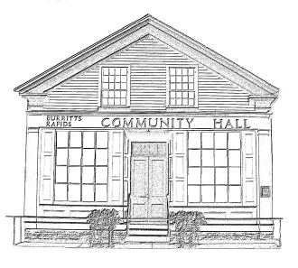
^{The} Burritt’s Rapids Community Association

Meeting of the Board of Trustees
Date: January 11 2012

Trustees Present:
John Dwyer, Patrick Gonneau, Renee Smith, Inge van Gemeren, Tiiu Wallner

Community Members Present:

None

Agenda:

- Minutes last month (John)
- Finances (Jill)
- Rental
- Theme Dinner
- Update
  - Hall Issues
  - Plaques
  - Ottawa Feedback Session
- Volunteer positions

Meeting Started: 7:05 pm

Minutes last month (John)

The minutes for the AGM were approved.

Finances (Jill)

Update to be provided in February. The Chairperson noted that the RV B&B donated $500 to the Association.

Rental

The Chairperson provided an update and Patrick noted that he needed to be kept apprised of the calendar.

Theme Dinner

The Chairperson updated the Board on developments. There was a discussion on the need to obtain auction items and to ensure the dinner was well attended.

Update

Hall Issues

Immediate needs included: key box; poster stands; lighting issues in Hall; ways to discourage unauthorized access to basement.

The Chairperson was to check home Deport for a key box; John was to purchase poster stands at Staples; Patrick was to check out lighting issues 9which might simply be the need for new lights); after much discussion, if was decided to replace door with a self-locking unit with a ‘panic bar’.

Longer term issues involved the need to replace ceiling and floor in the main Hall.

The Chair indicated that the Rental sign will need to be changed. John indicated that he could organize when he was back from a business trip.

Plaques

A wall mounting donated by the RV B& B will need to be suitably mounted.

Plaques in memory of Pat Stroulger and Hydro Ontario contributions were discussed.

Ottawa Feedback Session

There was discussion on how to approach the session on the upcoming Ottawa village planning. It was generally agreed that the Association should play a facilitative role only: the substantive issues being considered were those being put forward by the City of Ottawa, not the Village.

Volunteer Position

The Chairperson indicated that she could take over the rental agent responsibility and manage the website but could not also continue as the Chairperson.

There was a general discussion on how to proceed but no definitive decision was taken.

Next Meeting:

February 8 2012

Adjourned: 8:30 pm

