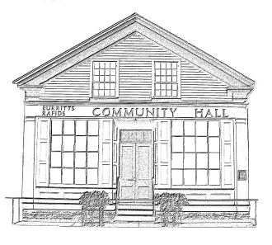
^{The} Burritt’s Rapids Community Association

Meeting of the Board of Trustees
Date: August 24 2011

Trustees Present:
John Dwyer, Renee Smith, Tiiu Wallner, Inge van Gemeren, Maureen Wilson

Community Members Present:

None

Agenda:

- Potential purchase of property along the Canal

Meeting Started: 7:00 pm

Possible Purchase of Land

The Chair, having previously consulted with members by phone, opened the meeting to discussion about the possible purchase of the said property by the Community Association.

Several members raised concerns about the possibility, including the cost, the goals of doing so – identified as including saving green space and community access as well as preserving the view – and whether the action would ensure that these goals were realized.

The Chair informed the members of more recent developments: the substantial contribution of an anonymous donor for the possible purchase; the discussions with the vendor being facilitated by Gary Talman which seemed to suggest that the land might be purchased for a sum close to the amount contributed anonymously since the community association could offer tax incentives and the privilege of naming the eventual green space to the vendor.

Members were also apprised that members not present had been consulted and were supportive of the initiative.

Members agreed that discussion should be pursued on the basis discussed with final decisions taken when more detail was known. Members noted that if the proposal were tentatively accepted, consultations with and confirmation from the community would be necessary. They also indicated the desirability of determining whether Parks Canada might also be a partner.

Meeting Ended: 7:40 pm

Next Meeting:

September 14 2011

Adjourned: 8:00 pm

