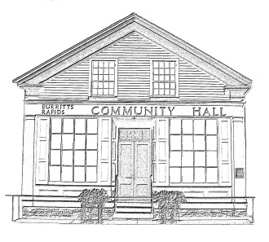
^{The} Burritt’s Rapids Community Association

Meeting of the Board of Trustees
Date: January 9 2013

Trustees Present:
John Dwyer, Patrick Gonneau, Jill MacDonald, Inge Vangemeren, Tiiu Wallner, Maureen Wilson

Community Members Present:

Agenda:

- Minutes last month (John)
- Finances (Jill)
- Update
  - Rental
  - Hall Maintenance
- Other items
  - PC/RVCA Shoreline Naturalisation Proposal
  - Heritage Community Designation
  - Theme Dinner

Meeting Started: 7:05 pm

Minutes last month (John)

The minutes of the AGM were not yet prepared, but John promised to do them by the 20th of the month.

Finances (Jill)

No update was presented.

Update

Rental

The Chairperson noted that the individual operating Cinema Obscura was going to offer a ‘magic camp’ for children during the March Break.

There was a general discussion on rental rates.

Hall Maintenance

Damage to the facia caused by ice build-up was noted. This was to be repaired when possible. Inge was to see if Chris could do it

The continuing need to repair the toilet was raised. It was decided that given the difficulties in getting Ian that Chris too might be asked to do the work with advice as needed.

Discussion was held on work on the Hall. Maureen and John were asked to talk further with Burritt’s Rapids resident (and former BRAC Chairperson) Andrea Cordonnier about her earlier offer to oversee the work.

Patrick updated the Board on completed repairs.

The Chairperson indicated that Burritt’s Rapids resident (and architect) David Simpson would assist in the design of the exterior front of the Annex to make it more reflective of the Hall’s heritage nature.

Other Business

PC/RVCA Shoreline Naturalisation Proposal

The meeting between Board Members (Inge, Tiiu & John) and representatives of Parks Canada and the Rideau Conservation Authority was discussed as was the record of that meeting prepared by PC. It was agreed that our own take on that meeting was to be prepared by John. It was also agreed that the Greening Committee would consider doing something itself, possibly with the RVCA, to deal with the erosion issue, but do so in a way that met Community needs, something that Parks Canada was unable to agree to.

Heritage Community Designation

The Chairperson updated the Board on the issue, including the possibility of involving Carleton University students in the process of looking at design designations for houses on Grenville Street.

Theme Dinner

Jill updated the Board on planning for the Dinner.

Next Meeting: February 13 2013

Adjourned: 8:30 pm

