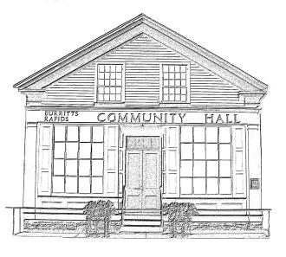
^{The} Burritt’s Rapids Community Association

Meeting of the Board of Trustees
Date: May 8 2013

Trustees Present:
John Dwyer, Patrick Gonneau, Inge Vangemeren, Tiiu Wallner, Maureen Wilson

Community Members Present:

Agenda:

- Minutes last month (John)
- Finances (Jill)
- Update
  - Rental
  - Hall Maintenance
- Other items
  - Plant Sale
  - Order of Ottawa

Meeting Started: 7:05 pm

Minutes last month (John)

The minutes were approved as presented.

Finances (Jill)

There was no financial update.

Update

Rental

Inge reported on rentals: Cinema Obscura has a disappointing turn-out at its last showing but would be coming back in September; Debbie was organizing a children’s Art Show for the end of the month

Hall Maintenance

Inge reported on a variety of repairs done and pending by community resident Chris Robertson as well as a few pending jobs.

There was a further discussion on the need for a transfer box; also discussed was the need for wiring the exit sign at the rear. Community resident Nickerson was to be approached.

The need for a fire extinguisher for the Hall was discussed and Maureen and John indicated that they would pick one up when in town.

John and Maureen were also to follow up with past-Chair Andrea Cordonnier regarding options for renovating the main room of the Hall.

New Items & Misc.

John and Tiiu reported on the (non) plant sale.

Inge informed the Board of the call for nominations for the Order of Ottawa.

Next Meeting:

June 12 2013

Adjourned: 8:30 pm

