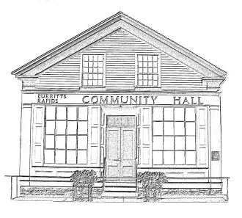
^{The} Burritt’s Rapids Community Association

Meeting of the Board of Trustees
Date: June 12 2013

Trustees Present:
John Dwyer, Patrick Gonneau, Jill MacDonald, Renee Smith, Tiiu Wallner, Maureen Wilson

Community Members Present:

Fairlie Ellis (start of meeting only)

Agenda:

- Minutes last month (John)
- Finances (Jill)
- Update
  - Rental
  - Maintenance
- Planning
  - Summer Picnic
- Other items
  - Signage for Tip-to-Tip

Meeting Started: 7:05 pm

Minutes last month (John)

The minutes were unanimously accepted as presented.

Finances (Jill)

The treasurer presented the financial picture, which remains positive. She still intends to close the TD chequing account and transfer funds to the RBC in Kemptville.

There was a discussion about the relatively higher costs incurred for hydro (heating) and what might be done to reduce these – including posting a sign to turn down the thermostat after Hall use.

Update

Rental

The rental agent was not present; however, discussion on the higher than expected cost of heating led to a discussion of rental rates and a need to ensure that these are sufficient to cover all costs.

Jill also informed the Board that the Church Dinner found dirty dishes prior to their event. It was agreed that the Board will need to discuss how to better police events to ensure that this does not re-occur.

Hall Maintenance

There was a discussion on the need for an emergency exit sign at the rear exit.

The issue of the pony-panel for a generator was raised again.

John reported that he had spoken to former Chair Andrea Cordonnier and she would oversee the development of a proposal for renovating the Hall.

Planning

Summer picnic

There was a lengthy discussion on a summer picnic, perhaps tied into the non-denominational church event scheduled for July 21.

Patrick indicated that the Masons might participate in the event.

There was a general discussion of events – consensus being that ‘traditional’ picnic games should be organized; Jill indicated that Pathfinders might do face-painting etc.

There was also agreement that follow-up planning was necessary but it was felt that this could be accomplished through e-mail exchanges.

Miscellaneous

The signage for the Tip-to-Tip trail was discussed and Renee agreed to follow-up with Classic Graphics to have one made for installation at the side of the Library.

Next Meeting: September 11 2013

Adjourned: 8:30 pm

