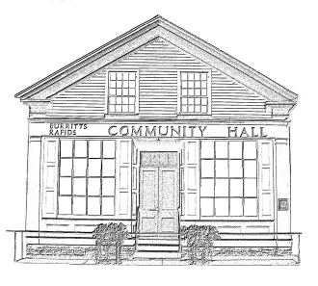
^{The} Burritt’s Rapids Community Association

Meeting of the Board of Trustees
Date: October 9 2013

Trustees Present:
John Dwyer, Patrick Gonneau, Jill MacDonald, Inge Vangemeren, Tiiu Wallner, Maureen Wilson

Community Members Present:

Agenda:

- Finances
- Update
  - Rental
  - Hall Maintenance
- Planning
  - AGM
- Other items
  - Greening Committee

Meeting Started: 7:05 pm

Finances (Jill)

The Financial Statement was accepted as presented.

Update

Rental

The rental agent noted that the Hall continues to be well-booked; for example the Hall is booked for 5 Saturdays over the next couple of months.

Hall Maintenance

Trustee Patrick Gonneau is to contact Tim Sutton re a defibulator.

It was noted that the front of the Hall needs painting. Trustee John Dwyer is to contact the Lezeit brothers to get an estimate.

The Board noted the good work done by Chris Robertson in repairing the eaves damaged last winter.

Planning

AGM

It was agreed that the AGM would be held on November 21st and that the format used for the last couple of AGMs would continue. The meeting would primarily be a casual “meet your neighbor” event even while the core requirements, such as reporting on the work of the Committee, would be met.

There was discussion on the need to expand membership on the Board as several members were stretched by family and other responsibilities and might not be able to continue. Discussion included the possibility of hiring someone to manage special events; the possibility of establishing a nominating committee; etc.

Tasks were discussed an assigned: Trustee John Dwyer is to get the wine and liquor license; Trustees Maureen Wilson and Tiiu Wallner will be organizing food and refreshments.

Other Business

Greening Committee

The Board reviewed the note sent by Fairlie Ellis which contained a number of positive suggestions for action. It was agreed that Chris Robertson would be approached to undertake a number of the initiatives proposed.

Next Meeting:

While not normally the case, the board agreed that it might be necessary to hold a meeting in advance of the AGM in November. This is to be confirmed as needed by the Chair.

Adjourned: 8:30 pm

